Jauntlet

Final Project

Report

I.E.S. San Vicente
San Vicente del Raspeig (Alicante)
2015/2016

Teacher:
José Ignacio Cabanes

Student:
Vicente Cuenca Reyes

1. Introduction
Project name
Jaulent

Made by
Vicente Cuenca Reyes

Short description of the project
This is an adventure game in which you can choose from four characters to get out of the dungeon .

2. Functionality of the project
When you start the game appear a brief history . When finished, the player must choose between the four playable characters and start your adventure.

During the game is to find keys , secret doors and defeat the enemies before they kill him.
The game will feature five levels and a boss to which we will have to kill to get beat the game and score in the ranking.

3. Screen prototype
The game screen will look like this:

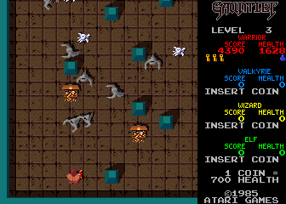

4.Analysis

4a. Requisites
Requisite | Date achieved
Make shots and correct collisions. | 23/05
Add life that comes down over time as heroes | 23/05
And add life to the enemies . | 24/05
Add doors and keys.
Correct the scroll to work properly | 23/05
Add food to increase health and break if it receives an attack
Add punctuation to kill enemies | 23/05
Make enemies persecute the character and when you remove life collide
Make monsters generators
Add to warrior
Add to mage
Add to and archer
Add sound to the game.
Add potions that can be used harming monsters
Homescreen with history
Screen credits and Ratings cooperative play
Make lava levels and hidden rooms ...
cooperative play
Make the final boss ( dragon ) This will be depending on the complexity of one or more days .

4b. Basic pseudocode

//TODO

4c. Classes diagram

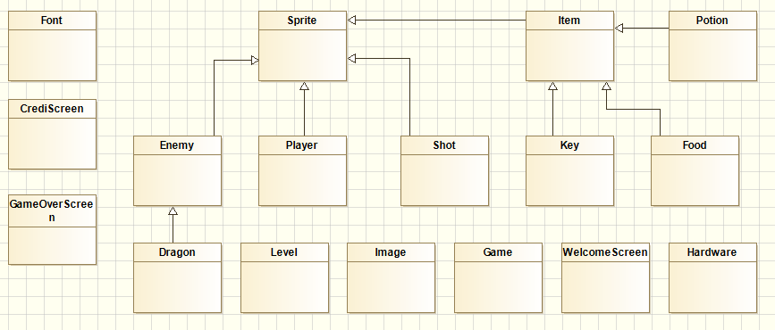

Add class Door : Sprite.

And Delete class Item because is empty

5. Initial planning and expected deliveries

5a. Expected deliveries

v.1: Make shots and correct collisions.
v.2: Add life that comes down over time as heroes
v.3: And add life to the enemies .
v.4: Add doors and keys.
v.5: Correct the scroll to work properly
v.6: Add food to increase health and break if it receives an attack
v.7: Add punctuation to kill enemies
v.8: Make enemies persecute the character and when you remove life collide
v.9: Make monsters generators
v.10: Add to warrior
v.11: Add to mage
v.12: Add to and archer
v.13: Add sound to the game.
v.14: Add potions that can be used harming monsters
v.15: Homescreen with history
v.16: Screen credits and Ratings cooperative play
v.17: Make lava levels and hidden rooms ...
v.18: cooperative play
v.19: Make the final boss ( dragon ) This will be depending on the complexity of one or more days .

5b. Real deliveries

20/05/2016: Make shots and correct collisions.
Correct the scroll to work properly
23/05/2016: Add life that comes down over time as heroes.
And add life to the enemies .
Add punctuation to kill enemies

24/05/2016 Convert Arrays in List
Generate Instances in fuction the level
Add Class Door
Make metod for Open Door.(not proved)

6. File formats

6a. Plain files format
The scores table is saved to a text file, which contains the name of a player in one line, and the corresponding score in the following line, and so on, to complete the 10 highest scores, as in this example:

//TODO

7. Problems found and solutions
I preferred not to use the SDL library directly, which I found difficult to learn, so I have used the classes "Hardware", "GraphicsElement" and "Font" that we had used previously in class games (...)

Although in the level 3 (hard) I check the next three movements, sometimes the computer makes foolish moves, but always in the first column. I have not found where the bug is, but I think the problem may lie in this portion of code, in which I check each column versus the previous one: (...)

I noticed that if I take the game to another computer which has not the DotNet Framework installed in it, the program closes without any error or warning message (...)

(…)

8. Improvements or restrictions to the starting design
I have had time enough to include the effect of animation when the pieces fall (…)

I have not been able to implement (…) because of (…)

9. Screenshots of the final project
(…)

10. Source code of the final project
(…)

